LINE FOLLOWING CAR

Student: Danci Patricia Ioana

Design with Microprocessors

Technical University of Cluj-Napoca
January 2025

Contents
Contents
Contents 2
Introduction 3
Bibliographic Research 4
2.1 Existing Applications 4
2.2 Analysis and Comparison 5
Proposed Solution and Implementation 5
3.1 Description of the Project 5
3.2 Implementation 6
Figure 1: Line Following Robot using ESP32 [2] 9
3.3 Algorithm Description 10
Figure 2: Flowchart 12
Testing and Validation 13
4.1 Challenges Encountered 13
4.2 Behavior Comparison 14
4.3 Possible Enhancements 14
Conclusion 15
Bibliography 15

Introduction
Robotics has seen significant advancements in recent years, especially in autonomous systems that mimic human and industrial tasks. Line-following robots are a foundational application, often used to automate repetitive tasks. These robots can track a pre-defined path and are widely used in manufacturing, logistics, and self-driving technologies.
Some real-world applications include:
- Tesla's Lane Detection: Leveraging advanced sensors and AI for lane-keeping assistance in autonomous vehicles.
- Amazon Robotics: Warehouse robots that follow pre-defined paths to optimize inventory management and delivery.
- Robotic Vacuum Cleaners: Devices that follow pre-set patterns to clean spaces efficiently.
This project was chosen out of a passion for cars and autonomous driving technologies. As a student aspiring to delve deeper into the automotive fields, creating a line-following robot served as an opportunity to explore fundamental concepts used in self-driving cars and automated systems. It combines my interest in cars with hands-on learning in microcontrollers, sensors, and motor control systems.
The prototype aims to design and implement a low-cost, functional line-following robot using the ESP32 microcontroller, IR sensors, and an H-Bridge motor driver. The robot can navigate along a black line and take turns when required. Overall, this solution demonstrates how simple, readily available components can work together to achieve autonomous line-following functionality.

Bibliographic Research
The concept of this project revolves around creating a robot capable of autonomously following a pre-defined path, represented by a black tape on a white surface. The robot uses infrared sensors to detect the path and makes decisions to turn left, right, or stop when necessary. This behavior is controlled by an ESP32 microcontroller, which processes input from the sensors and sends signals to the motors via an H-Bridge motor driver. The project demonstrates the fundamental principles behind path-following technologies, such as lane assist in modern vehicles, on a simpler and more accessible scale.

2.1 Existing Applications
Following the examples provided in the introduction, I will mostly delve into the automotive industry, where most notable applications of path-following technology are implemented. These applications consist of Lane Assist Systems, which play a vital role in increasing road safety and supporting semi-autonomous driving. Lane assist systems use cameras, LiDAR, and radar to detect road markings and guide vehicles within their lanes. These systems can provide alerts or even take corrective actions, such as steering adjustments, to prevent unintentional lane departure.
Currently, Lane Assist Systems monitor the car’s position on the road, detect if the driver is unintentionally leaving their lane and reacts either through warnings or by actively steering the car back into its lane. [1]
The first lane assist system as we know it was introduced by Mercedes on their European Actros trucks in the late 1990s, with Nissan, Toyota and Honda offering lane assist systems on various passenger models in the early 2000s but mainly limited to the Japanese market. [1]
Over the years, each car manufacturer has started to implement such technologies, with their own specifications.
For instance, Tesla Autopilot utilizes an array of sensors and cameras to detect lane markings and maintain the vehicle’s position within the lane, enhancing the driving experience and safety. Furthermore, BMW Lane Keeping Assistant offers active steering to keep the car in its lane while monitoring surrounding traffic, while Toyota Lane Departure Alert (LDA) alerts drivers when unintentional lane deviation is detected and applies minor steering corrections if necessary.
These systems are examples of advanced technology that combines sensor input with real-time decision-making algorithms. While this project operates on a much simpler level, it mimics the core functionality by using IR sensors to follow a pre-defined path.

2.2 Analysis and Comparison
While professional automotive lane assist systems rely on sophisticated technology such as:
- Cameras for visual recognition of lane markings.
- LiDAR for precise environmental mapping.
- AI Algorithms for decision-making in dynamic traffic conditions.
This project demonstrates a scaled-down version of the same concept using basic components:
- IR Sensors: Instead of cameras, the robot uses infrared sensors to detect a high-contrast black line on a white surface.
- H-Bridge Motor Driver: Provides simple control over motor movement, allowing the robot to turn and move forward or backward.
- ESP32 Microcontroller: Processes sensor data and implements the decision-making logic.
Key Differences:
- Technology: Professional systems use cutting-edge AI and advanced sensors; this project uses simple, accessible components.
- Cost: Lane assist systems are part of expensive vehicles, while this project is highly cost-effective and designed for educational purposes.
- Complexity: Industrial solutions handle dynamic environments, while this project operates in a controlled, static setup.
The prototype highlights how foundational concepts in professional applications can be implemented at a simpler level for learning and experimentation.

Proposed Solution and Implementation

3.1 Description of the Project
This project aims to design a functional and cost-effective line-following robot that:
- Detects and follows a black tape path using IR sensors.
- Takes left or right turns based on sensor input.
- Stops or performs a 180-degree turn when no path is detected.
The robot uses the following components:
- ESP32 Microcontroller: Processes sensor data and controls motor movements.
- IR Sensors: Detect the presence of the black line by sensing light intensity.
- H-Bridge Motor Driver: Enables bidirectional control of the motors.
- DC Motors: Drive the wheels of the robot for movement.
- Chassis: Houses all components and provides structural support.
This project demonstrates how readily available and affordable components can be used to implement basic autonomous navigation, similar to foundational technologies in modern self-driving vehicles.

3.2 Implementation
Hardware Components
- ESP32:
  - A microcontroller with built-in Wi-Fi and Bluetooth, making it versatile and ideal for autonomous systems.
  - Handles the logic and control of the robot.
- H-Bridge Motor Driver (L298N):
  - Allows bidirectional control of two motors by using four input pins connected to the ESP32.
- IR Sensors:
  - Two IR sensors placed at the front of the robot detect the black line.
  - Connected to the ESP32 to provide real-time input for navigation.
- Motors and Wheels:
  - Two DC motors control the rear wheels for movement.
  - A free-moving wheel at the front provides balance.
- Power Supply:
  - A 6V battery pack powers the robot.
  - ESP32 is powered via the battery through the VIN pin for autonomous operation.

Circuit Diagram
The robot’s hardware is connected as follows:
- IR Sensors: Connected to GPIO pins 33 and 32 of the ESP32.
- H-Bridge:
  - IN1 (left motor forward): GPIO 27.
  - IN2 (left motor backward): GPIO 26.
  - IN3 (right motor forward): GPIO 13.
  - IN4 (right motor backward): GPIO 12.
- Motors: Connected to the H-Bridge’s output terminals.
- Battery: Connected to the H-Bridge for powering the motors and ESP32.

Circuit Connection Overview
The robot’s circuit connects the ESP32 microcontroller to various components to achieve the desired functionality. The IR sensors provide input, while the H-Bridge motor driver controls the motors based on signals received from the ESP32. The connections are optimized for simplicity and functionality.
To enhance flexibility during development, Wi-Fi OTA (Over-the-Air) updates were implemented. This allowed uploading code wirelessly without requiring a physical USB connection to the ESP32. Additionally, an Access Point (AP) mode was set up for the ESP32 to create its own network, enabling remote programming and debugging.

Wiring Diagram
The wiring connections are as follows:
- IR Sensors:
  - Left IR sensor output → GPIO 33.
  - Right IR sensor output → GPIO 32.
  - Both IR sensors’ VCC and GND → Breadboard power rails (3.3V and GND, respectively).
- H-Bridge Motor Driver:
  - IN1 (Left motor forward) → GPIO 27.
  - IN2 (Left motor backward) → GPIO 26.
  - IN3 (Right motor forward) → GPIO 13.
  - IN4 (Right motor backward) → GPIO 12.
  - H-Bridge VCC → 6V battery pack.
  - H-Bridge GND → ESP32 GND.
- Motors:
  - Left motor → H-Bridge OUT1 and OUT2.
  - Right motor → H-Bridge OUT3 and OUT4.
- Power Supply:
  - ESP32 VIN → H-Bridge 6V power rail.
  - ESP32 GND → Common ground.

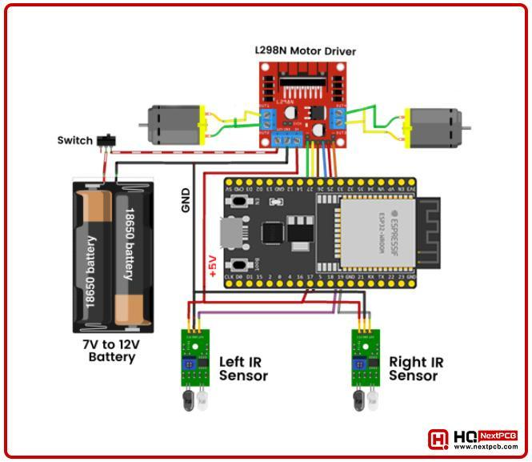

Figure 1: Line Following Robot using ESP32 [2]

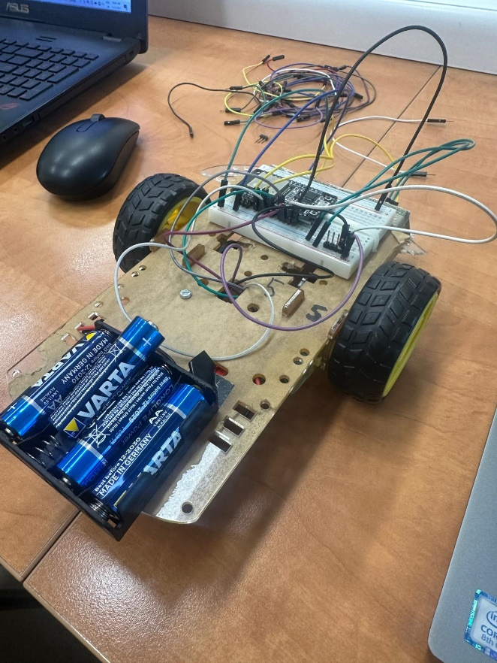
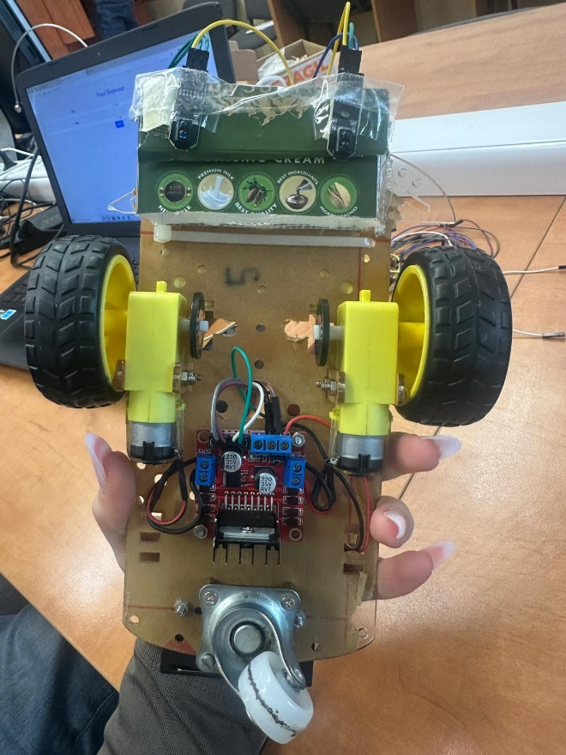
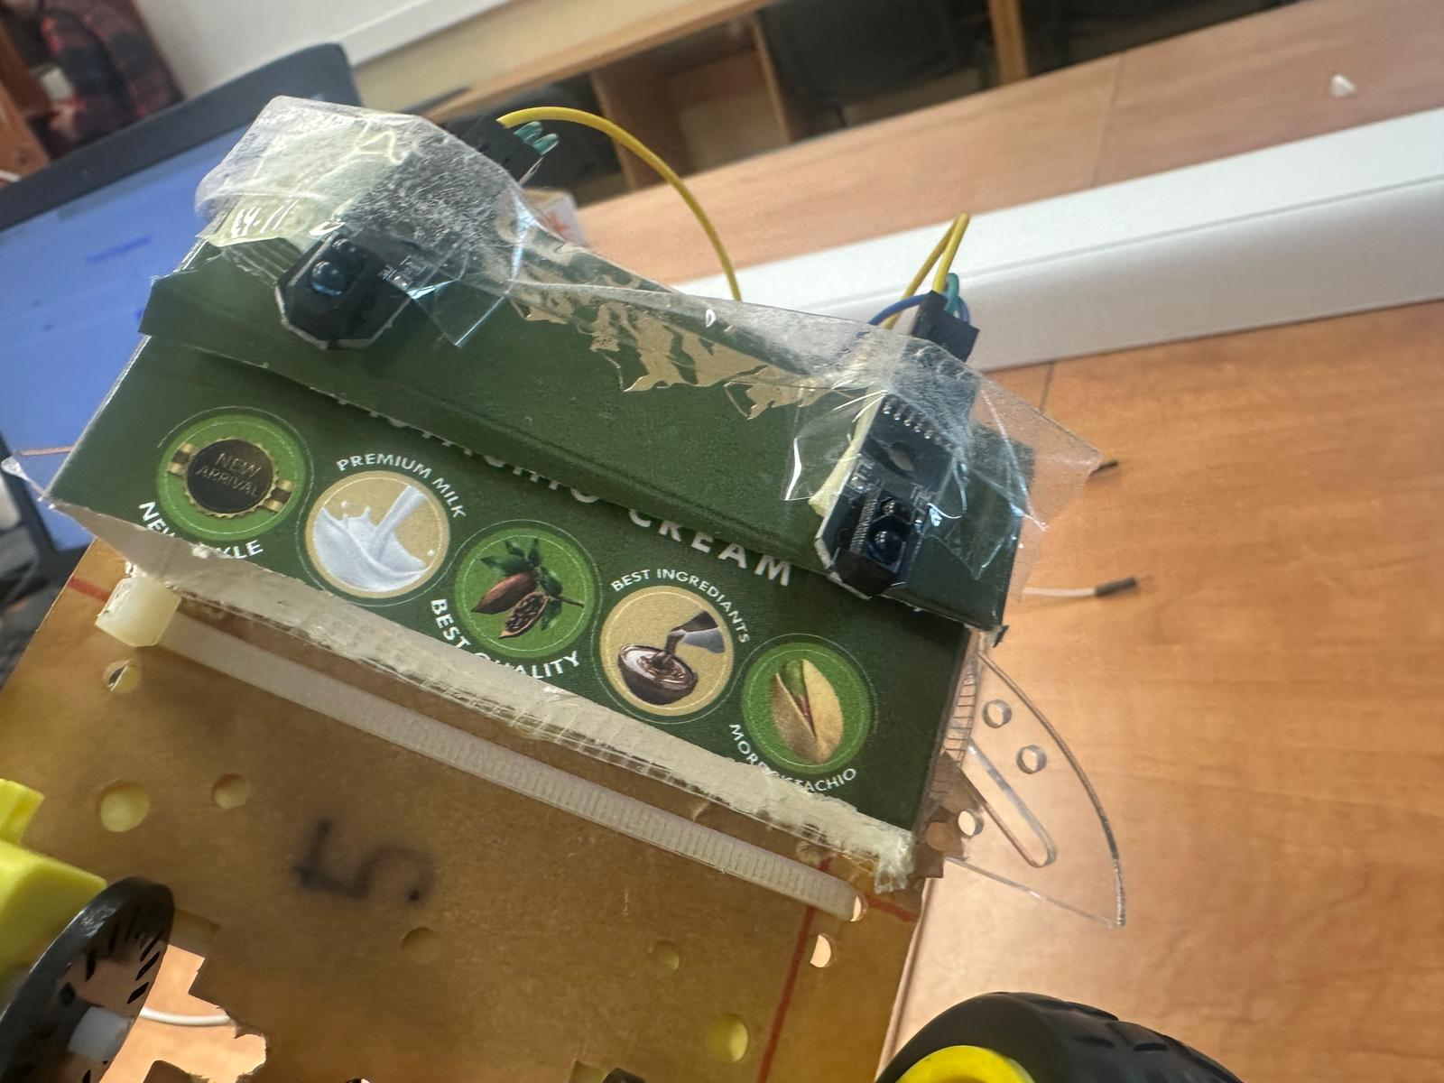

Figure 2: Prototype

Software Implementation
The robot’s software is written in C++ and uploaded to the ESP32 via the Arduino IDE. It is structured to:
- Read inputs from the IR sensors.
- Control motor outputs based on sensor readings.
- Implement movement logic for line following and path correction.

Code Methods
- moveForward():
  - Sets the H-Bridge pins to drive both motors forward.
- turnLeft():
  - Stops the right motor and drives the left motor forward to achieve a left turn.
- turnRight():
  - Stops the left motor and drives the right motor forward to achieve a right turn.
- stopMotors():
  - Stops both motors.
- turnBack():
  - Rotates the robot 180 degrees by driving one motor forward and the other backward.

Libraries and Dependencies
The project uses the following libraries:
- WiFi.h:
  - Used to connect the ESP32 to a Wi-Fi network for OTA updates.
- ArduinoOTA.h:
  - Enables Over-the-Air programming of the ESP32, allowing code updates without a USB connection.

3.3 Algorithm Description
Main Logic
The line-following robot uses a simple decision-making algorithm that processes input from two infrared (IR) sensors to determine its actions. The algorithm ensures the robot can:
- Follow a black line by moving forward.
- Take left or right turns when required.
- Stop or perform a 180-degree turn when the black line is no longer detected.
The algorithm's primary decision points are:
- Both IR sensors detect black (LOW): The robot moves forward.
- Left IR sensor detects black (LOW), and the right sensor detects white (HIGH): The robot turns left.
- Right IR sensor detects black (LOW), and the left sensor detects white (HIGH): The robot turns right.
- Neither IR sensor detects black (HIGH): The robot stops or performs a 180-degree turn.

Algorithm Steps
- Initialize motor control pins and IR sensor input pins.
- Continuously read the values from the IR sensors:
  - LOW indicates the sensor is above a black surface.
  - HIGH indicates the sensor is above a white surface.
- Evaluate the sensor values and determine the robot's movement:
  - Move forward if both sensors detect black.
  - Turn left if only the left sensor detects black.
  - Turn right if only the right sensor detects black.
  - Stop and turn back if neither sensor detects black.

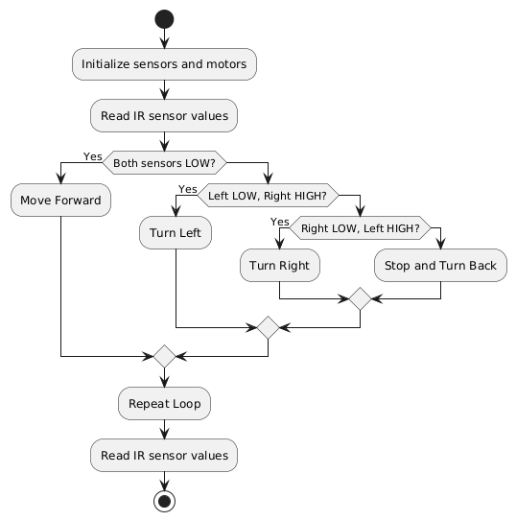

Figure 3: Flowchart

The algorithm is implemented as follows:

void loop() {
// Read IR sensor values
int leftSensor = digitalRead(IR_LEFT); // LOW = Black line, HIGH = White
int rightSensor = digitalRead(IR_RIGHT); // LOW = Black line, HIGH = White

// Movement logic
if (leftSensor == LOW && rightSensor == LOW) {
moveForward(); // Both sensors detect black
} else if (leftSensor == LOW && rightSensor == HIGH) {
turnLeft(); // Left sensor detects black
} else if (leftSensor == HIGH && rightSensor == LOW) {
turnRight(); // Right sensor detects black
} else {
turnBack(); // Both sensors do not detect black
}

delay(50); // Short delay for stability
}

Testing and Validation

4.1 Challenges Encountered
During the development and testing phase of the line-following robot, several challenges were identified and addressed:
- Sensor Calibration:
  - Issue: Initially, the IR sensors failed to differentiate effectively between the black line and the white surface, resulting in incorrect readings.
  - Solution: Adjusted the height of the sensors and modified the code logic to interpret HIGH and LOW signals correctly.
- Motor Speed:
  - Issue: The robot moved too fast due to the absence of speed control (PWM), causing instability, especially during turns.
  - Solution: Managed the speed indirectly by implementing precise turning logic that stopped one motor while the other remained active.
- Battery Power:
  - Issue: The ESP32 required consistent and sufficient power to function properly. The initial 6V battery pack occasionally caused the ESP32 to reset.
  - Solution: Switched to powering the ESP32 via USB during testing, ensuring reliable operation.
- Connection Stability:
  - Issue: The OTA (Over-the-Air) setup sometimes failed due to weak Wi-Fi signals or interference.
  - Solution: Improved the connection by ensuring the ESP32 was within a strong Wi-Fi signal range during programming.

4.2 Behavior Comparison

Scenario | Expected Behavior | Observed Behavior
Both sensors detect black | Robot moves forward | Robot moved forward as expected
Left sensor detects black, right does not | Robot turns left | Robot turned left smoothly
Right sensor detects black, left does not | Robot turns right | Robot turned right smoothly
Neither sensor detects black | Robot stops or performs a 180-degree turn | Robot stopped or turned back as programmed

Overall, the robot's observed behavior closely matched the expected outcomes.

4.3 Possible Enhancements
- Add Speed Control:
  - Implement PWM for smoother and adjustable motor speed.
- Improve Sensor Precision:
  - Use higher-quality IR sensors or integrate a camera module for better path detection.
- Expand Functionality:
  - Add obstacle avoidance using ultrasonic sensors for more complex navigation.
- Increase Stability:
  - Upgrade the chassis and wheels for smoother movement on uneven surfaces.
- Enhance Connectivity:
  - Utilize Wi-Fi mesh or Bluetooth for better OTA performance in environments with weak signals.

Conclusion
This project successfully demonstrated the design and implementation of a low-cost, functional line-following robot using the ESP32 microcontroller. Despite the use of simple, readily available components, the robot showcased reliable autonomous navigation, mimicking foundational concepts utilized in advanced applications such as lane assist technologies in modern vehicles.

Bibliography
[1] John Tallodi, "What is lane assist" April 14, 2022
[2] Line Following Robot using ESP32
[3] Espressif Systems. ESP32 Technical Reference Manual. Espressif Systems, 2022
[4] How to Make a Line Follower Robot Using Arduino

